Dear participants of the exhibition
“Russian Education Forum 2013"!
Please read the information contained in this letter. In order to avoid overlaps and confusion adhere the terms specified in the letter, and follow the recommendations!

Director General | Aleksei Haryutkin, e-mail: avh@moskaumesse.com
Project Manager | George Boyko, e-mail: boyko_ga@moskaumesse.com
Tel. | (495) 995-05-91. Ext.426
Fax | (495) 995-05-91
Venue | Moscow, Sokolniki Exhibition and Convention Centre, Pavilion 4.1
Participants registration  place and time | March 25, 2013, 9.00 am – 09.00 pm  March 26, 2013, 09.00 am – 10.00 am
 | Sokolniki Exhibition and Convention Centre, Pavilion 4.1, the Organizer’s Office

The General Event Period and the Fixed Event Period Schedule
Monday  March 25, 2013 | 9.00 am – 9.00 pm | Participants’ arrival
Tuesday  March 26, 2013 | 9.00 am – 6.00 pm  10.00 am – 5.00 pm | Pavilion working hours  Visiting hours
Wednesday  March 27, 2013 | 9.00 am – 6.00 pm  10.00 am – 5.00 pm | Pavilion working hours  Visiting hours
Thursday  March 28,2013 | 10.00 am – 4.00 pm  4.00 pm – 10.00 pm | Visiting hours  Participants’ departure

Dear participants!
Departure from the exhibition, as well as the removal of exhibits before 04:00 p.m. on March 28 is strictly prohibited!

Extra time for mounting and disassembling is paid according to the form № 7.
You can order and pay for the extension of mounting time at the arrival day in the directorate of the exhibition before 04:40 p.m. In case of extension of mounting time you must provide a list of mounting team (2 copies) to the exhibition directorate.

CATALOG
Brief information about yourself (company name, address block, activity) can be provided by filling in the form № 4 and sending it to the exhibition directorate.
We inform you that the materials to the official catalog should be submitted until February 15, 2013. Organizer does not guarantee the placement in the catalog of companies which have not provided the information prior to this date.
ENTRANCE TO THE EXHIBITION TERRITORY
During the mounting and dismantling of booths the entrance to the hall is carried out by form № 6.1. Entrance to the exhibition for the participants carried out from 09:00 a.m. strictly on badges.
Issuance of badges will take place at the counter of exhibition directorate on March 25, 2013 from 09:00 a.m. to 06:00 p.m.
To order badges, you must fill out and submit to the management the form № 5 until March 13, 2013.
BUILD-UP
Exhibitors, who have ordered the connection of electricity to the booth, should send the application (form № 3) to the exhibition directorate. We remind you that the orders made on March 13 and further, subject the extra charges amounting to 50% of the order value and 100% - the orders made on March 25 and further.
Three-phase power supply will be implemented only if the Exhibitor has an electrical panel and a cable length of at least 30 m of corresponding section.
In the absence of a cable and an electrical panel Exhibitor can order them in Messe Design.
Connection of the Exhibitor’s equipment to the source of power supply is made after the execution of works by measuring of the resistance, checking-up the insulation of electric circuit and provision the necessary documents.
Works on the connection and adjustment of electrical appliances are executed by exhibitors themselves.
For the exhibitors, who build their stands independently (exclusive), it is necessary to be accredited at Sokolniki ECC, contact our manager, Maksim Ilyukhin (tel: +7 (495) 995-05-95, ext. 434, e-mail: iluhin_mv@sokolniki.com. The companies failing to pass accreditation are not allowed for build-up
The exhibitors, who have ordered the equipped exhibition area, are required to agree on the booth with the exhibition directorate until March 13, 2013
ATTENTION! In the case the Exhibitor has not submitted the booth plan within the specified period, the Organizer constructs the booth to the standard model. Replanning of the construction is executed at the expense of the Exhibitor at the rate of 60% of the cost of the equipment of the paying day.
We remind you that the orders made on March 13 and further, subject to extra charges amounting to 50% of order value and 100% the order made on March 25 and further.

ATTENTION! During the mounting power supply to the booths is not provided. Electricity for mounting is provided from the electric panel by outlets (220 V) with the Exhibitor’s own extension cord.
Cargo handling operations
On the schedule for coming of companies with heavy equipment and on the cargo handling, please call: 8 (495) 995-05-95, ext.491. Contact person: Andrei Yegorov.
Please, send the application for cargo handling services to the e-mail aae@sokolniki.com
Upon the application the schedule of arrival / departure is worked out. The date of arrival / departure of your organization, you can also learn from Pavel Revenko. In the case of a late application submission Organizer is not responsible for the full and timely delivery / removal of the exhibitor’s equipment.
We remind you that the orders made on March 13, 2013 and further subject to extra charges amounting to 50% of the cost.
Attention: companies who have ordered cargo handling! Loading and unloading are made only by the Organizer’s means of hardware (forklift, crane).

DOCUMENTS REQUIRED FOR MOVING IN
Prior to moving in at the exhibition, the Exhibitor makes out the letter for the bringing in / bringing out of exhibits in 3 copies (form № 6.1) with the stamp of the company and the head of the company signature.
The letter contains the equipment and exhibits that you bring in and will bring out, including furniture, windows, computers, advertising products, etc.
ORDER OF MOVING IN
Moving in of the tricks with the exhibits is performed by the street “3 Luchevoi prosek” under the pointer “Завоз экспонатов” (Delivery of exhibits). In the days of moving in, all vehicles traveling under pointer «Завоз экспонатов" through “3 Luchevoi prosek” are free of charge if you have the form № 6.1 with your signature and stamp. You pass to the mounting gates of pavilion 4 (see diagram), submit to the directorate the letter for brining the equipment in and out (form № 6.1, 3 copies) with stamp and signature of the Director of your company. In the directorate you get to put down the stamp "Ввоз разрешен” (Bringing in is permitted) on the letter, which allows you to bring the equipment into the pavilion. After the end of the exhibition you will have to get the stamp " Вывоз разрешен” (Bringing out is permitted) on the letter and show it to the guard of the pavilion at the exit. Stamps «Ввоз разрешен» and «Вывоз разрешен» are put by the Directorate if you have no debts to Sokolniki services!
During mounting and dismantling (see above) coming in the park by the car t is possible if you have a letter (form № 6.1), during the exhibition (see above) coming in the territory of the park is carried out on presentation of the participant’s badge.
Parking at the mounting gates after unloading is strictly prohibited!
During bringing in of the exhibits all the packaging / containers should be removed from the exhibition area on the day of moving in to avoid conflicts with the fire service. The storage of containers can be ordered and paid for by you in “Trans Expo” Ltd.
CLEANING
During the exhibition the cleaning of aisles and trash removal is performed from special places.
Keeping booths clean, and cleaning of the occupied area is made by the Exhibitor. You can order the cleaning from the Organizer of the exhibition (form № 7).
Every day at the end of the exhibition at 06:00 p.m. all the garbage from the booths, placed in baskets, you need to put in the aisle between the exhibition booths.
SECURITY
During mounting / dismantling of the exhibition the pavilions are taken under guarding from 09:00 p.m. to 09:00 a.m.
During the exhibition - from 18.00 p.m. to 09.00 a.m.
In order to ensure the safety of your exhibits, each company shall appoint a person responsible for the booth, who must be present at the booth:
• during the mounting on March 25 from 09:00 a.m. to 21:00 p.m.;
• during the exhibition from on March 26 - 27 from 09:00 a.m. to 06:00 p.m. on March 28 from 09:00 a.m. to 04:00 p.m.
Organizer is not responsible for the safety of your exhibits!
Individual guarding of the booth can be ordered by form № 7.

REQUIREMENTS FOR PROMOTIONS
Any demonstration or activity that impedes the movement of visitors in the aisles or prevent from access to the nearby exhibition booths will be terminated. For the convenience of visitors the exhibitors should provide space for promotions within their stand.
Distribution of advertisements of other exhibitions, as well as promotional materials of the organizations, firms, companies that do not take direct part in the exhibition throughout the whole territory of the exhibition is STRICTLY prohibited.
In case of violation of this paragraph Organizer reserves the right to apply sanctions to the Exhibitor, such as closing of the booth without compensation and returning the money paid by Exhibitor to the Organizer for participation in the exhibition.
ORIGINAL DOCUMENTATION ROTATION AT THE EXHIBITION

You’ll receive your copies of Application-Agreement, invoices and acceptance certificates at the Organizer’s stand on the 3rd exhibition day.

ELECTRONIC REGISTRATION AND LETTERS OF INVITATION
Entrance is free.
ATTENTION! Please kindly inform your potential visitors that if they register at www.schoolexpo.ru.
You can also get some free invitation tickets at the Organizer’s Office.

HOW TO GET TO THE EXHIBITION
Address:
Moscow, 5 Luchevoi prosek, 7, building 1
Municipal transport to ECC “Sokolniki”:
Subway station “Sokolniki”, then walk to the ECC Sokolniki.
A free shuttle bus will be running during the exhibition from the subway station “Sokolniki” to Sokolniki ECC. Bus timetable is on the website www.schoolexpo.ru, Visit us section
To get by car:
• Coming in the ECC Sokolniki is through 3 Luchevoi prosek.
• Coming out the territory the ECC Sokolniki through Maisky prosek.

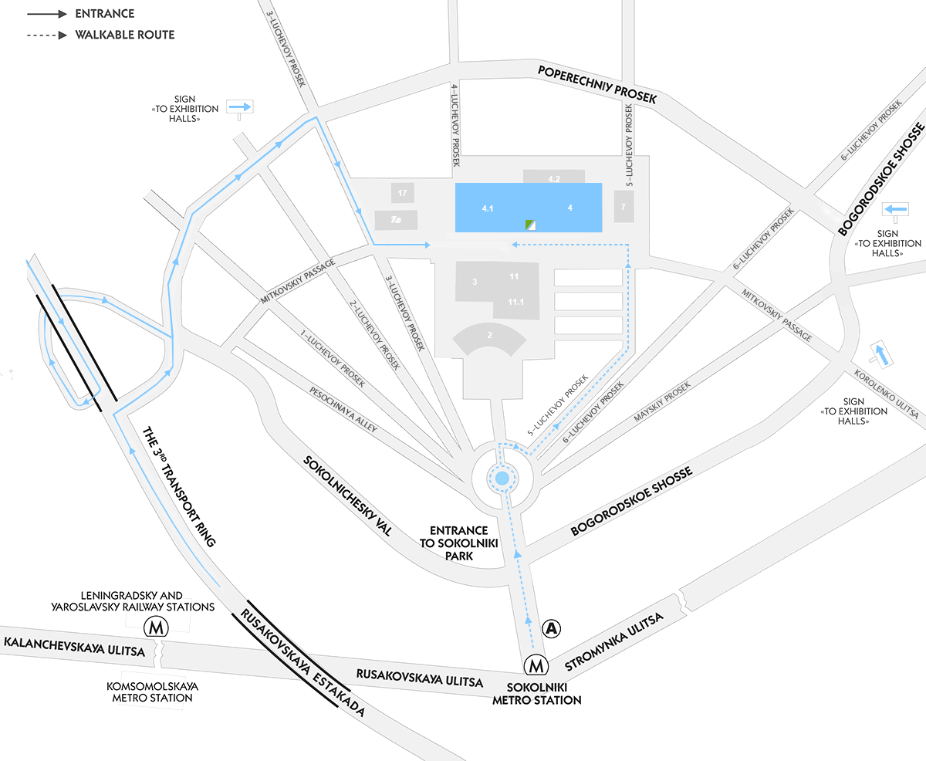

FORM № 6.1

Stamp of directorate

Exhibition: Russian Education Forum 2013 |  |  | Company:
 |  |  | Pavilion:
Tel./fax: | (495) 9950591 ext.426 |  | №: of the booth:
е-mail: | Boyko_ga@moskaumesse.com  avh@moskaumesse.com |  | Tel.:  Contact person:
Web: | www.schoolexpo.ru |  | E-mail:
Contact person: | George Boyko

№ | Name and brief description of cargo (exhibit) | Unit of measurement | Quantity

The letter for bringing in/bringing out should be submitted in THREE (3) copies with the director signature and the round stamp to the directorate of the exhibition at the moving in day. Please, enumerate EVERYTHING you will bring in and out!

Exhibitor:

Signature__________________

Date_____________________

Place
for stamp_____________________

